BAPTIST CHURCH

***October***

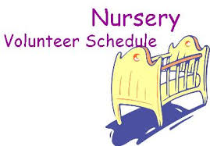

**Oct 5……………Paula Knobloch**

**Oct 12…………...Shirley Marecle**

**Oct 19…………...Terri Edwards**

**Oct 26………….Jana Moore**

**Weekly Service & Activity Schedule:**

SUNDAY

Sunday School 9:45 a.m.

Morning Worship Services 11:00 a.m.

Evening Worship Services 6:00 p.m.

WEDNESDAY

Youth Worship 7:00 p.m.

Wednesday Services 7:00 p.m.

1662 CR 305

McDade, TX 78650

Phone: (512) 273-2743

Email: [KnobbsSpringsBaptist@gmail.com](mailto:KnobbsSpringsBaptist@gmail.com)



*KnobbsSpringsBC.com*

Pray for our Pastor Search Committee

**Other Contacts**

*Cleyon Davis – Treasurer*

(512) 856-2524

*Patti Radford - Office Manager*

*KnobbsSpringsBaptist@gmail.com*

512-273-2743

**October Ushers**

Geary McManus, Mickey Stanford,

Terry Robinson, Joe Wilson

**October Hostesses**

Terri Edwards, Judy Broussard

WHAT’S GOING ON?



Meets the first Sunday of every month!! Grades: Kinder – 5th 12:00 - 1:30 with lunch served after church!!



High Attendance Sunday – Oct 26

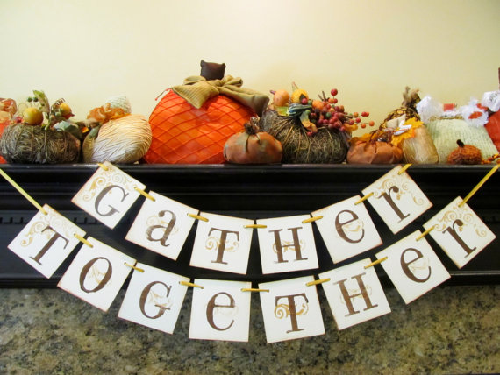

Harvest Stew - Nov 8 Come and join in fellowship!



Oct.

9 Adult Fellowship

12……….Kids In Action/Business Meeting

19 ..Independence Assoc. Annual Meeting

23………….……Adult Fellowship – 10am

26………………..High Attendance Sunday

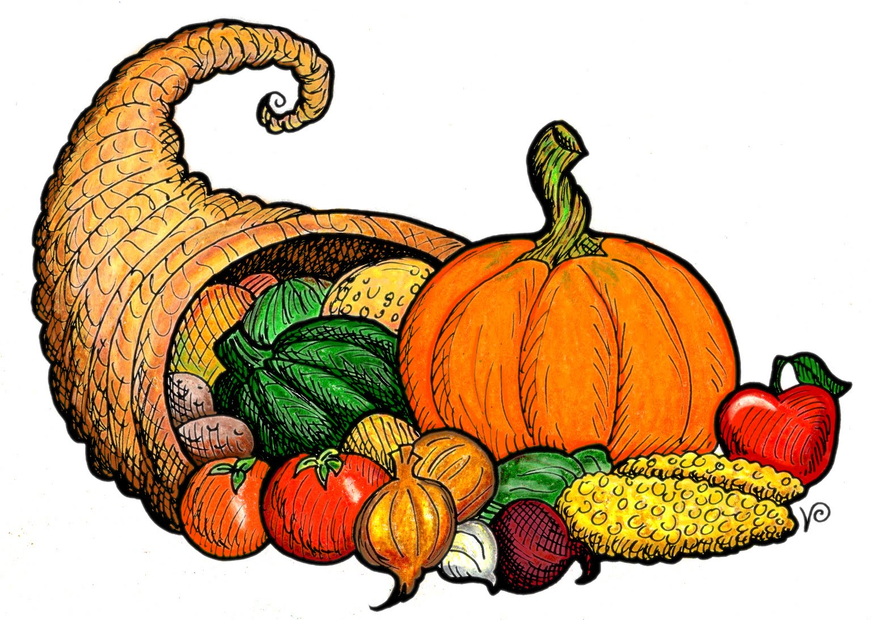

November

2 Kids In Action

3-14 Thanksgiving Basket Food Collection

8 Harvest Stew

9 Business Meeting

13 Adult Fellowship – 10am

16…………………..BGCT Annual Meeting

27…………..…………………Thanksgiving

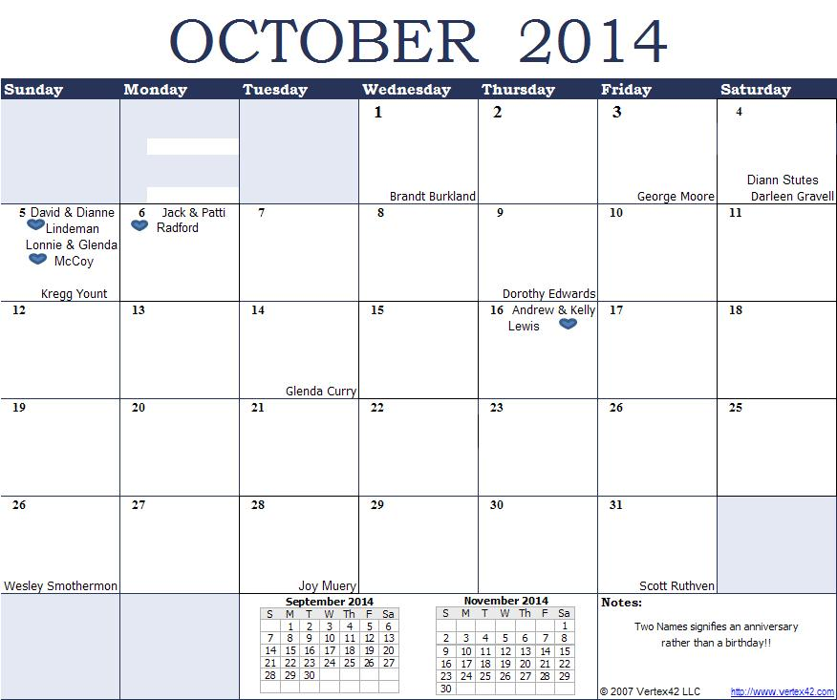

K s b c

**K**eeping His Word through **S**unday School, **B**ible Study and **C**hurch Attendance/Worship

Sunday School Bible Studies for October:

**October 5th Connected in Service *Ephesians 5:15-21* October 12th Connected through Prayer *Ephesians 6:18-22* October 19th Overcome Betrayal Genesis 37:19-27; 39:1-2 October 26th Overcome Temptation Genesis 39:3-12**

**9:45 a.m. each Sunday – A place for everyone**

**WE’D LOVE FOR YOU TO JOIN US!**